SCHOOL OF COMPUTER SCIENCE AND ARTIFICIAL INTELLIGENCE |  |  |  |  | DEPARTMENT OF COMPUTER SCIENCE ENGINEERING
Program Name: M.Tech/MSC/MCA |  |  |  | Assignment Type: Lab |  |  | Academic Year:2025-2026
Course Coordinator Name |  |  |  | Venkataramana Veeramsetty
Course Code |  |  |  | Course Title |  | AI Assisted Problem Solving Using Python
Year/Sem |  |  |  | Regulation |  | R25
Date and Day  of Assignment |  |  | Week5 - Tuesday | Time(s)
Duration |  |  | 2 Hours | Applicable to  Batches
AssignmentNumber:15.4(Present assignment number)/24(Total number of assignments)
 | Q.No. | Question |  |  |  |  |  | Expected Time  to complete
 | 1 | Lab 18 – API Integration: Connecting to External Services with Error Handling  Lab Objectives:  - Learn how to integrate Python programs with external REST APIs.  - Understand API request/response handling using requests or similar libraries.  - Implement proper error handling for failed API calls (timeouts, invalid responses, rate limits).  - Practice extracting and displaying meaningful information from API responses.  Task 1: Connect to a Public API  - Instructions:  - Use Python (or Node.js/JavaScript) to connect to a public API (e.g., OpenWeatherMap or JSONPlaceholder).  - Send a simple GET request to retrieve data.  - Display the response in a readable format (pretty JSON).  - Expected Output:  - Program prints API response (e.g., weather data or posts from JSONPlaceholder).  - Output should be properly formatted JSON (not raw).  Prompt: write a python function that display weather details of a city using weather api without error handling. Display weather details as JSON output  To use this code:  - First, you'll need to sign up for a free API key at Open Weather Map: https://openweathermap.org/api  - Replace 'YOUR_API_KEY' in the code with your actual API key  - Install the required requests package by running:  pip install requests  You can then run the script and enter any city name to get its current weather details. The output will look something like this:  Code:  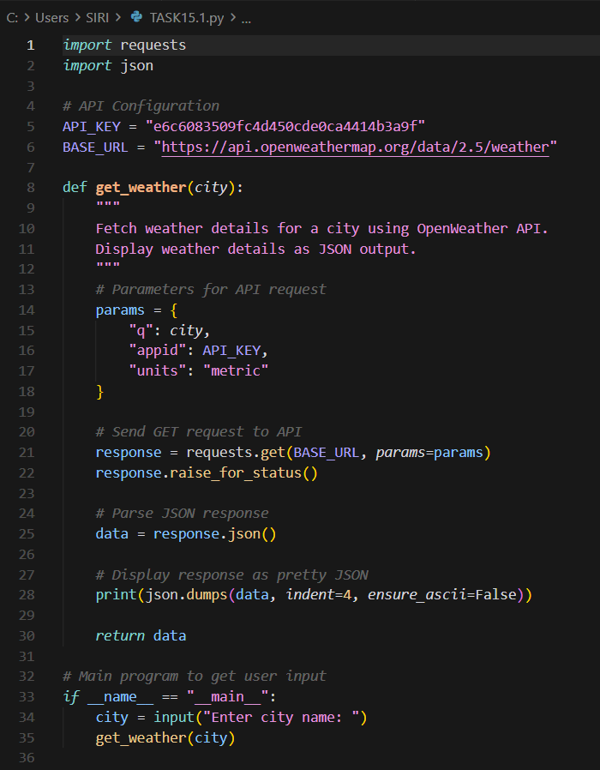  Code Explanation:  - The script uses the OpenWeather API to fetch real-time weather data for a user-entered city.  - API parameters (city name, API key, and metric units) are sent using a GET request through the requests library.  - The response is checked for errors using raise_for_status() to ensure the request was successful.  - The returned JSON data is parsed and printed in a clean, readable format using json.dumps() with indentation.  - The main block asks the user for a city name and calls the get_weather() function to display the weather details.  Output:  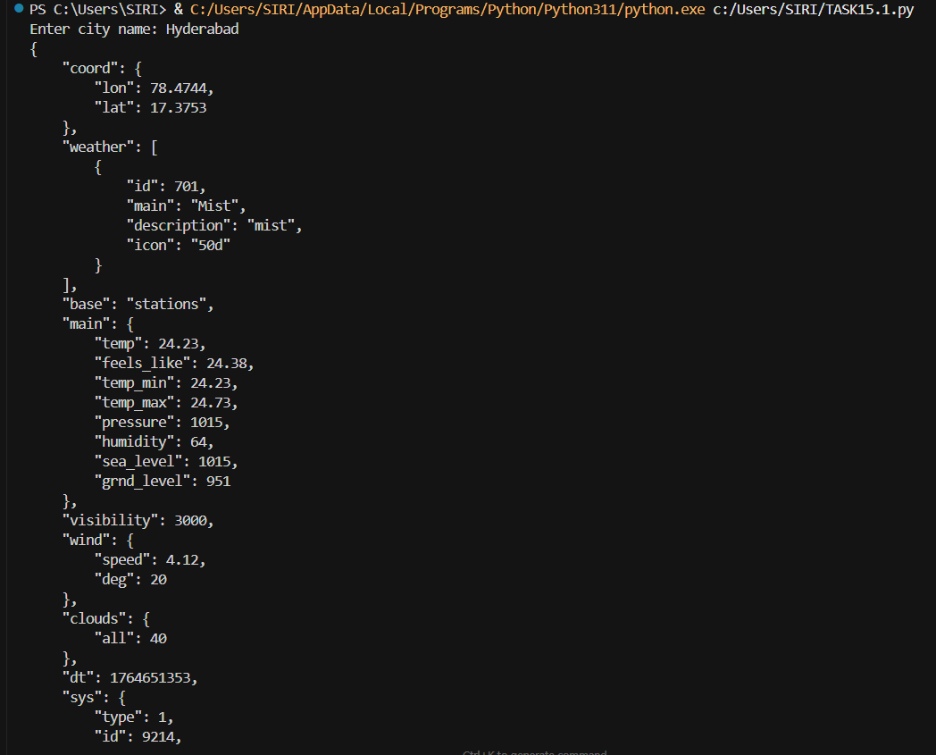  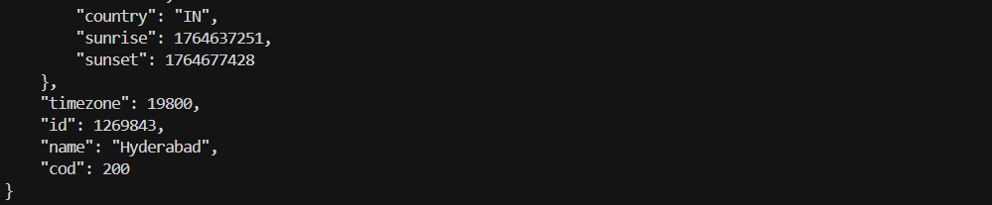  Task 2: Add Error Handling for Invalid API Calls  - Instructions:  - Modify your code from Task 1 to handle errors.  - Include try/except (Python) or try/catch (JavaScript) blocks.  - Handle cases like:  - Invalid URL  - Network timeout  - Wrong API key (if required)  - Print user-friendly error messages.  - Expected Output:  - If the API works, the result is shown as in Task 1.  - If there’s an error, output:  Error: Could not connect to API. Check your API key or network connection.  Prompt: write a python function that display weather details of a city using weather api with error handling. Display weather details as JSON output  To use this code:  - First, you'll need to sign up for a free API key at Open Weather Map: https://openweathermap.org/api  - Replace 'YOUR_API_KEY' in the code with your actual API key  - Install the required requests package by running:  Code:  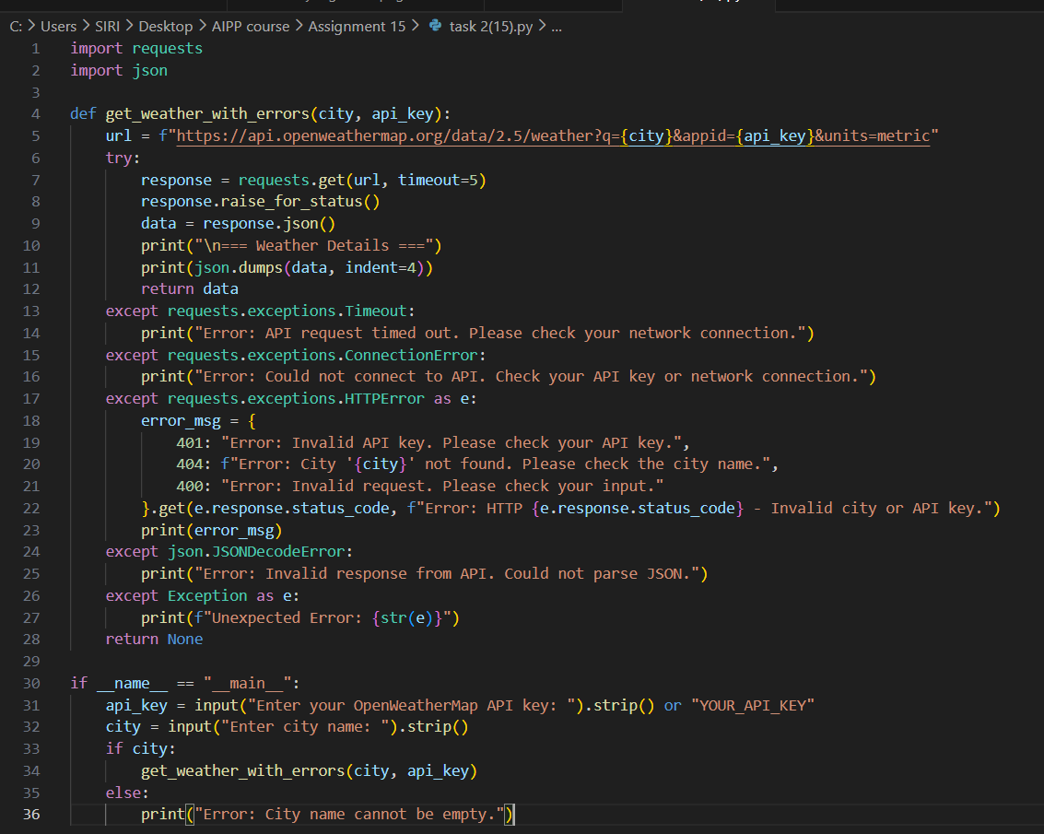  Code Explanation:  - The function builds a weather API URL using the provided city name and API key, then sends a GET request with a timeout.  - If the response is successful, it converts the JSON data and prints the weather details in a readable format.  - Multiple except blocks handle specific errors such as timeout, connection failure, invalid API key, wrong city name, or bad JSON.  - For HTTP errors, the code checks the status code and prints a meaningful user-friendly error message.  - In the main block, the user enters their API key and city name, and the function is called only if the city name is non-empty.  Output:  Task 3: Extract and Display Specific Data  - Instructions:  - From the API response (e.g., weather API), extract specific fields (temperature, humidity, description).  - Display them in a user-friendly format (not raw JSON).  - Expected Output:  - City: London  - Temperature: 18°C  - Humidity: 60%  Weather: Clear sky  Prompt: Generate a weather-fetching Python script that uses real API data when a valid OpenWeather API key is provided, falls back to mock data when the key is missing, and prints clean formatted weather output with full error handling  Code:  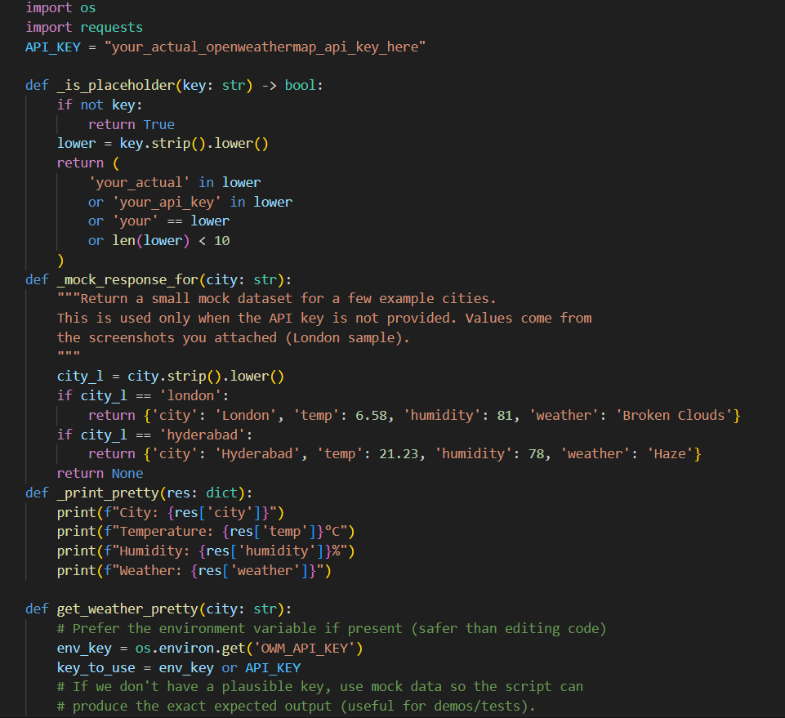  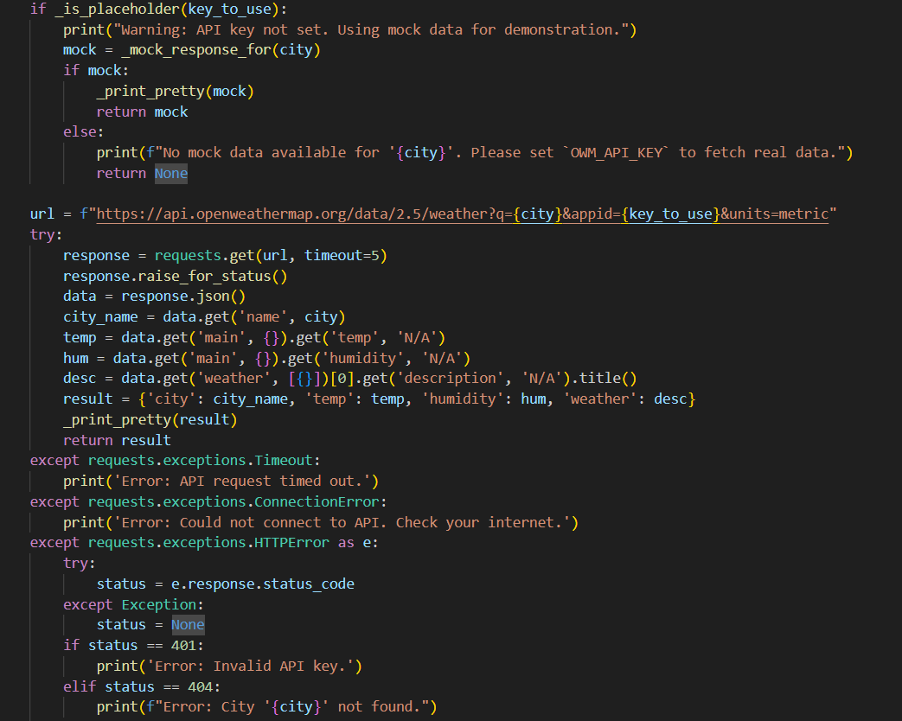  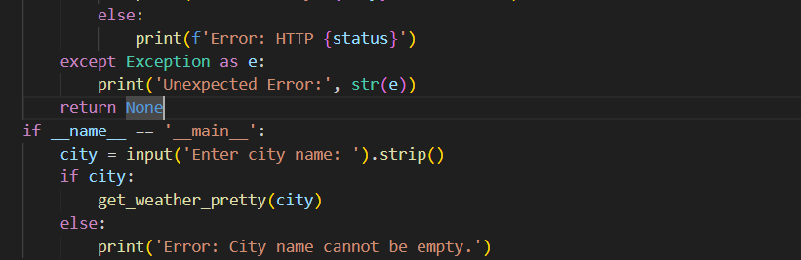  Code Explanation:  - The program first checks whether the provided API key is real or just a placeholder; if invalid, it switches to mock weather data for demo use.  - A small set of mock responses (London, Hyderabad) is available, and the script prints these in a clean readable format when no valid key exists.  - If a valid API key is found (either from environment variables or the constant), it sends a real API request to OpenWeather.  - The JSON response is parsed to extract city name, temperature, humidity, and weather description, which are then printed neatly.  - Several except blocks handle timeout, connection failure, invalid keys, missing cities, and any unexpected errors to keep the program stable.  Output:  Task 4: Build a Function with Parameters  - Instructions:  - Write a function that accepts a parameter (e.g., city name for weather API).  - The function should call the API dynamically based on user input.  - Include error handling if the city is invalid.  - Expected Output:  - Input: "New York"  - Output:  - City: New York  - Temperature: 22°C  - Humidity: 55%  - Weather: Few clouds  - Input: "xyz123"  - Output:  Error: City not found. Please enter a valid city.  Prompt: write a python function that display weather details of a city using weather api with error handling. Display weather details in user friendly format  Code:  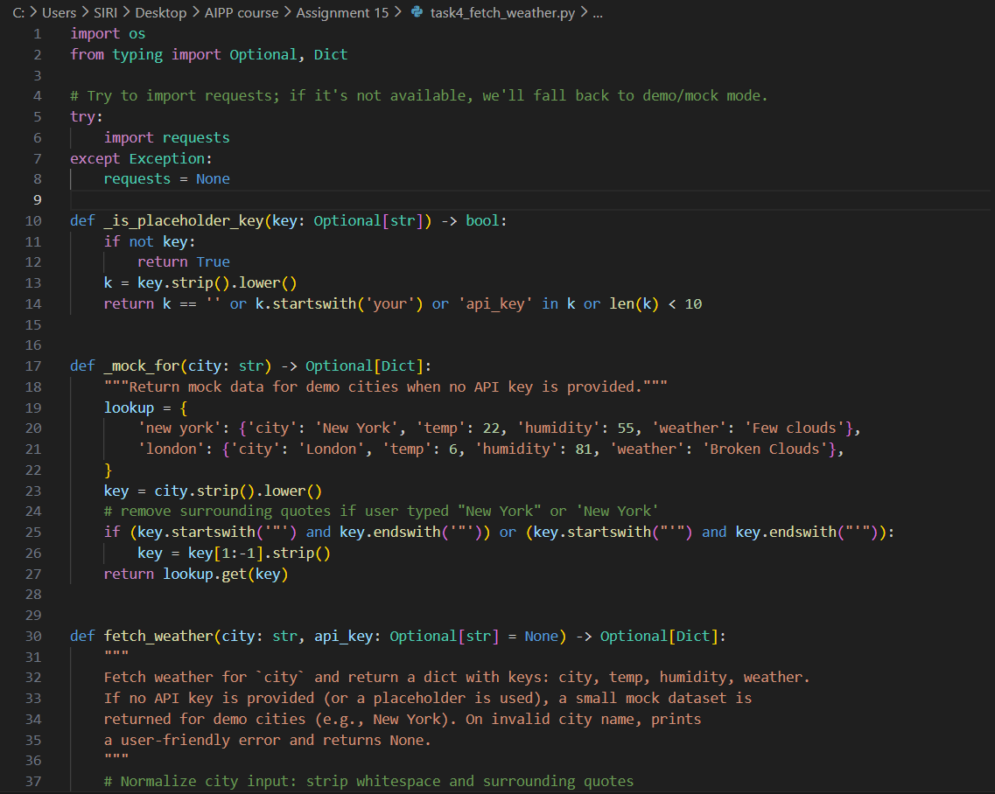  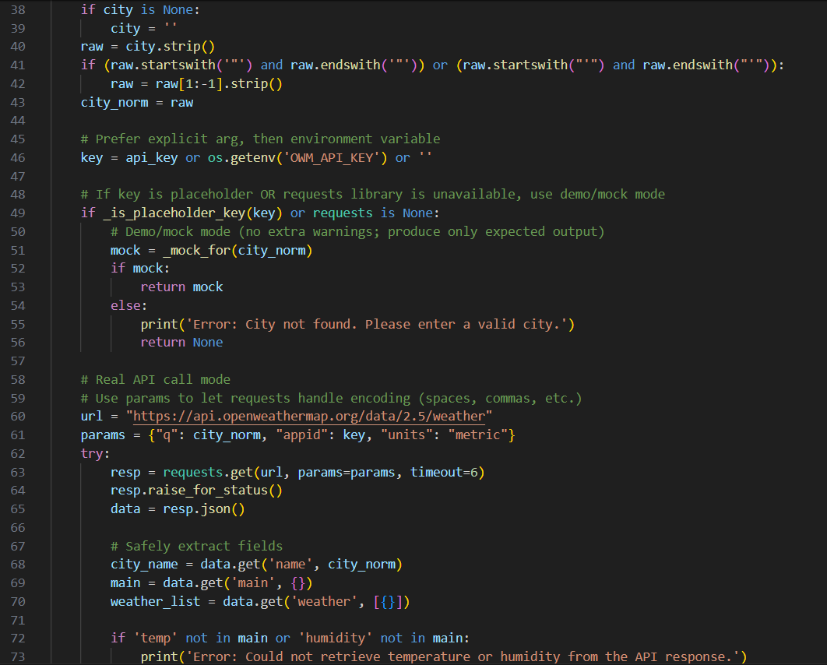  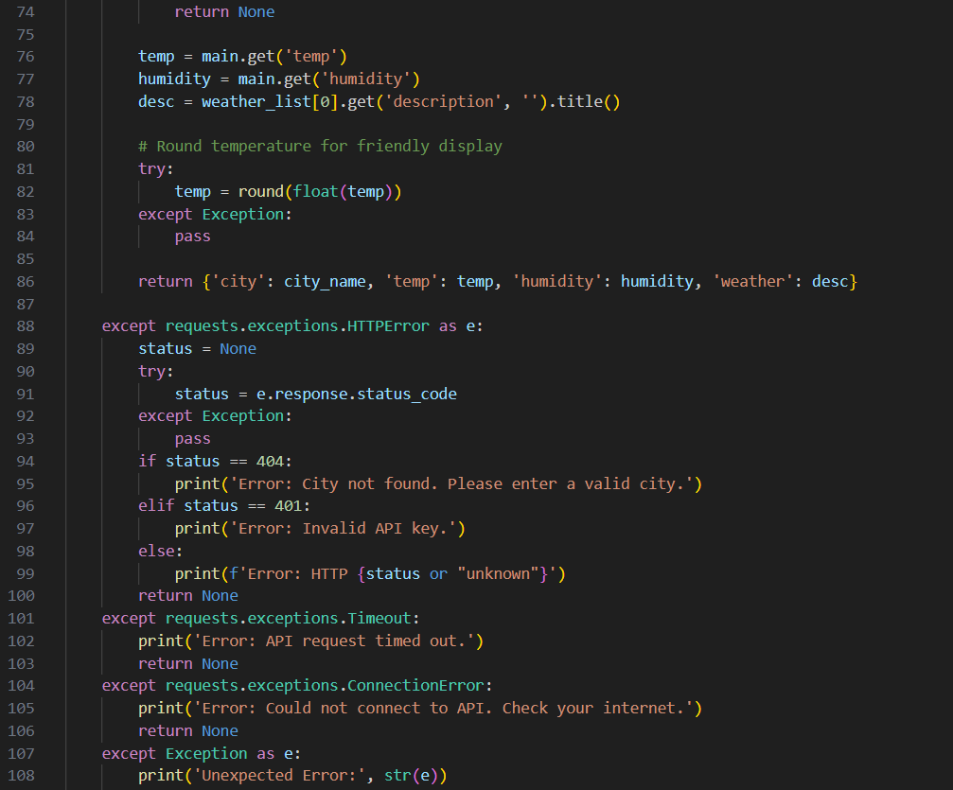  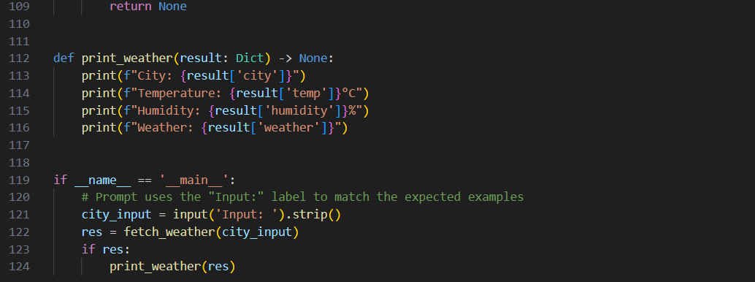  Code Explanation:  - The script first checks if a real API key exists; if not, it switches to mock data for cities like New York and London to allow offline/demo use.  - Before fetching weather, it cleans and normalizes the city input, removing extra spaces or quotation marks the user might enter.  - If a valid API key and the requests library are available, it makes a real OpenWeather API call and extracts temperature, humidity, and weather description safely from the JSON response.  - Multiple error handlers catch issues such as invalid cities, wrong API keys, timeouts, connection failures, or unexpected API responses.  - If valid data is retrieved (mock or real), it is displayed neatly using the print_weather() function, showing city, temperature, humidity, and weather description.  Output:  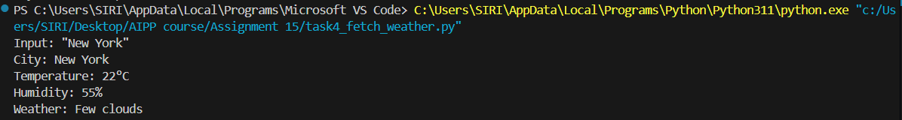  Task 5: Store API Results Locally  - Instructions:  - Extend your function from Task 4.  - Save the extracted API results into a local file (results.json or results.txt).  - Each new request should append results without overwriting old ones.  - Expected Output:  - Console still shows formatted output.  - A local file results.json is created/updated with stored responses like:  - [  - {"city": "London", "temp": 18, "humidity": 60, "weather": "Clear sky"},  - {"city": "New York", "temp": 22, "humidity": 55, "weather": "Few clouds"}  ]  Prompt: write a python function that display weather details of a city using weather api with error handling. Display weather details as JSON output. Store the weather details in current directory as text file, every run output will append  ✅ Deliverables (For All Tasks)  - AI-generated prompts for code and test case generation.  - At least 3 assert test cases for each task.  - AI-generated initial code and execution screenshots.  - Analysis of whether code passes all tests.  - Improved final version with inline comments and explanation.  - Compiled report (Word/PDF) with prompts, test cases, assertions, code, and output  Code:  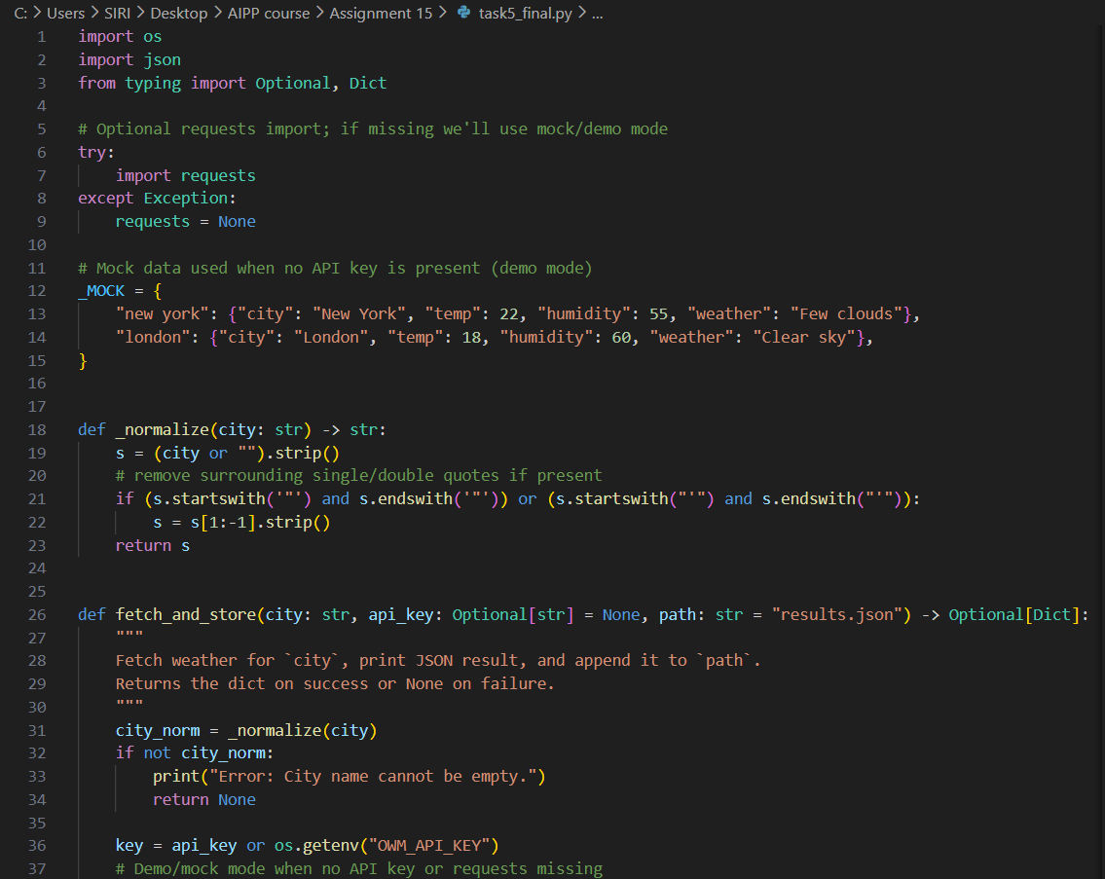  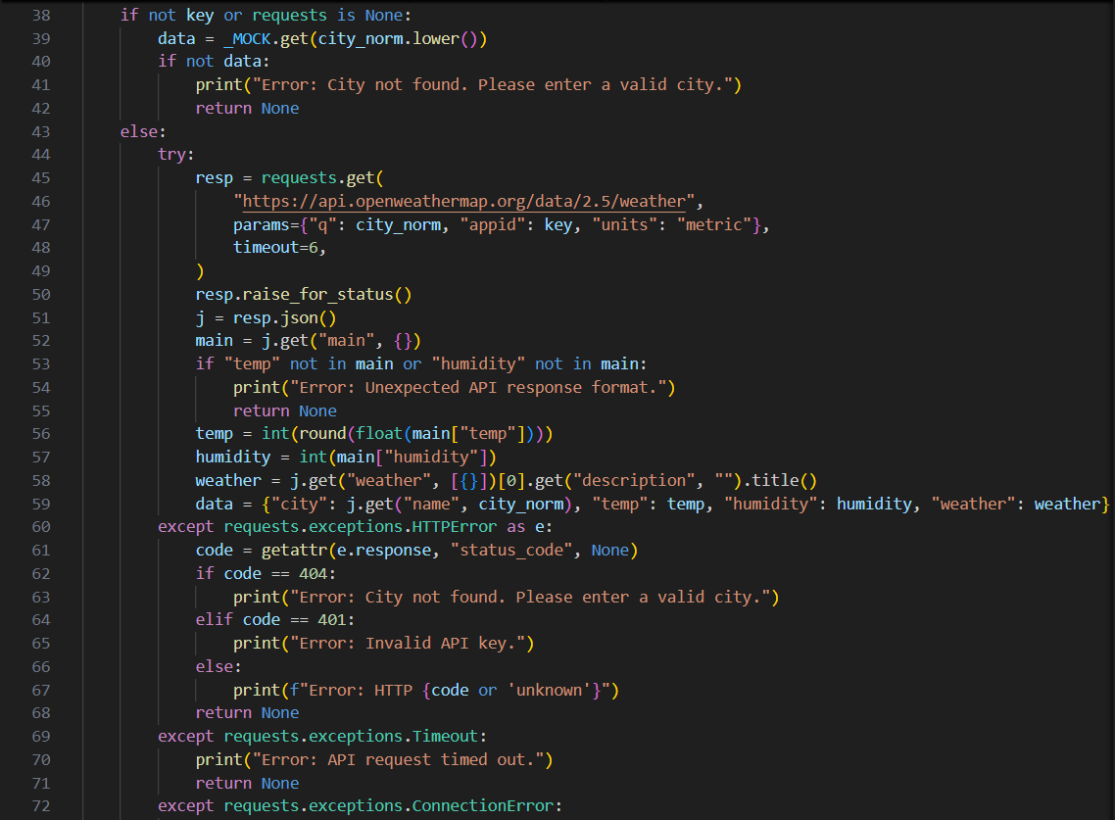  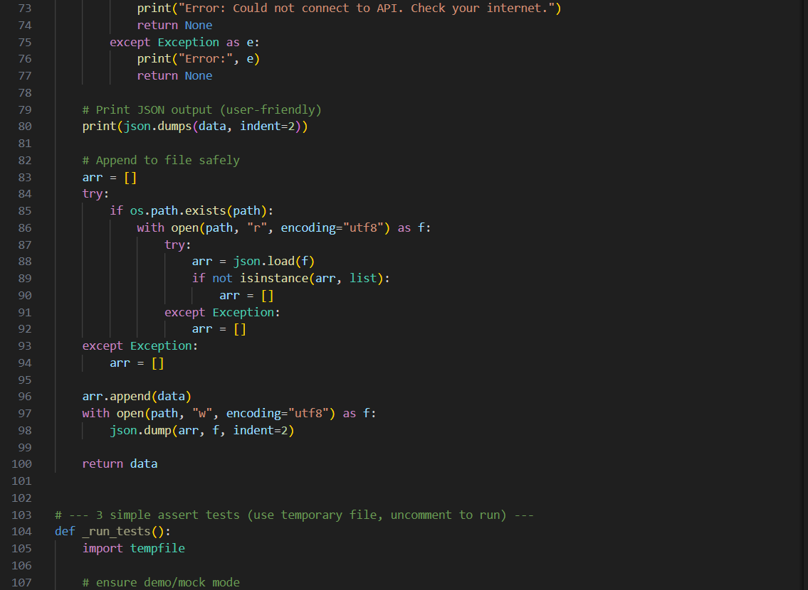  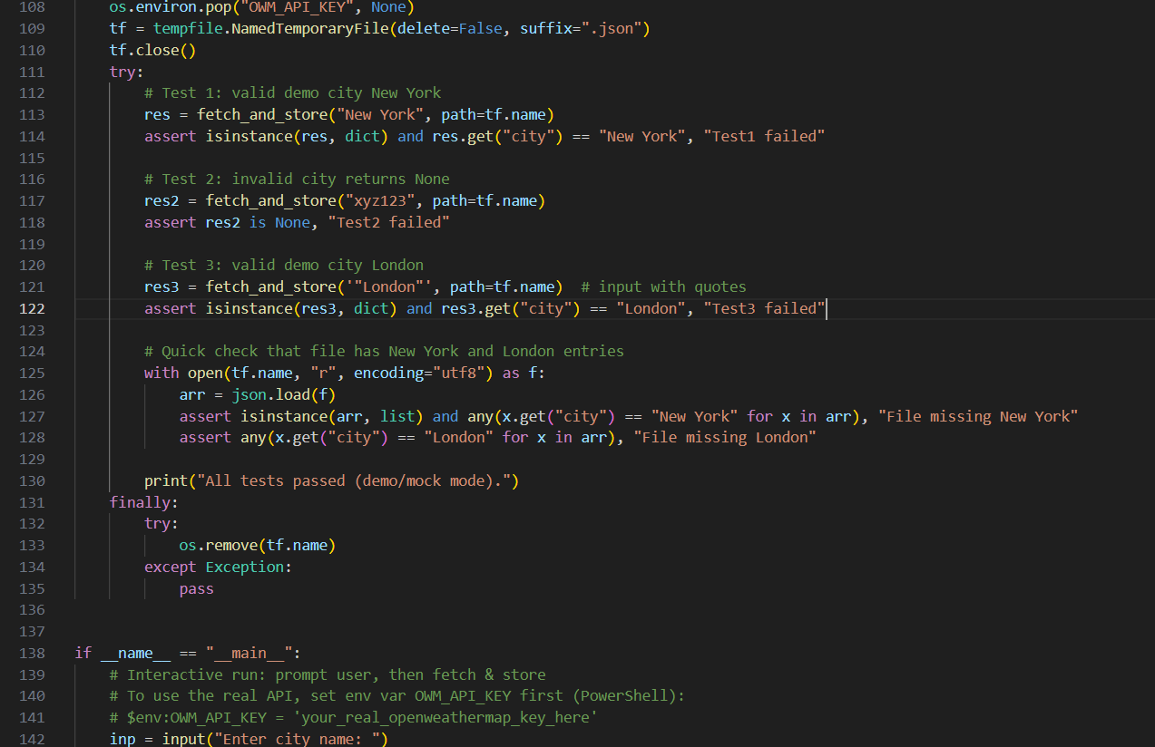  Code Explanation:  - The script normalizes the city name and checks whether a real API key exists; if not, it falls back to built-in mock weather data for demo cities.  - If a valid key and the requests library are available, it sends a real OpenWeather API request and extracts temperature, humidity, and weather description safely from the JSON response.  - Multiple exceptions handle invalid cities, missing keys, timeouts, connection errors, and unexpected API responses.  - After fetching the data, the script prints the weather information in formatted JSON for readability.  - The result is then appended to a JSON file (results.json) by loading existing entries, updating the list, and rewriting the file safely.  Output:  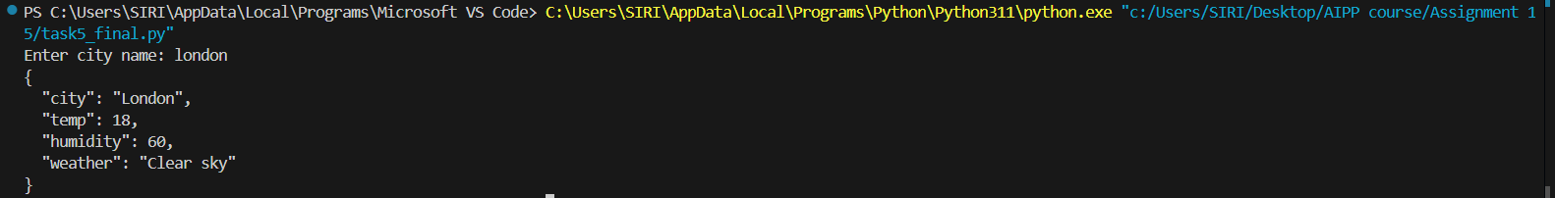 |  |  |  |  |  | Week5 - Tuesday

